Decision Making Statement
_________________________________________________________________________________
Decision making statement is used for to check the conditions or to perform conditional programming.

Types of decision making statement
___________________________________________________________________________
1. Simple if statement: Simple if statement means you can check the single condition by using simple
there no other option of condition

Syntax: if (condition)
{ Write here your logics
}
Other program statement.
Example: WAP to input two values and check which is greater
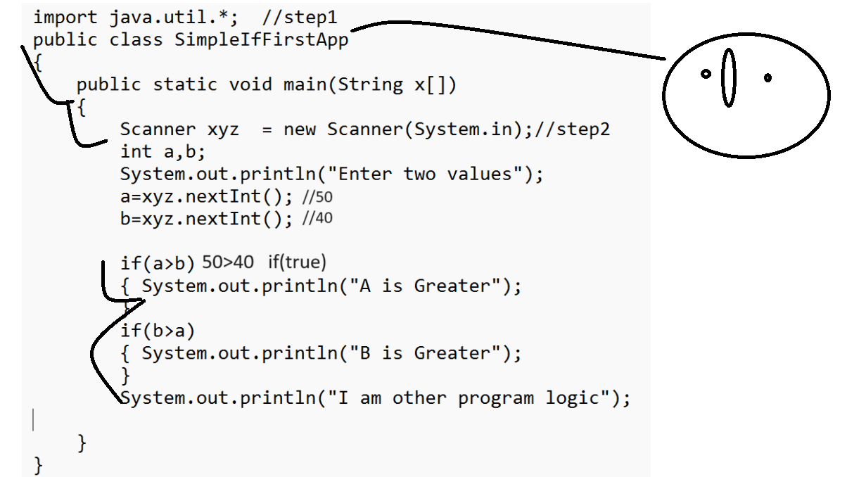

import java.util.*; //step1
public class SimpleIfFirstApp
{
public static void main(String x[])
{
Scanner xyz = new Scanner(System.in);//step2
int a,b;
System.out.println("Enter two values");
a=xyz.nextInt();
b=xyz.nextInt();

if(a>b)
{ System.out.println("A is Greater");
}
if(b>a)
{ System.out.println("B is Greater");
}
System.out.println("I am other program logic");

}
}

Example: WAP to input number and check number is divisible by 5 or not using simple statement
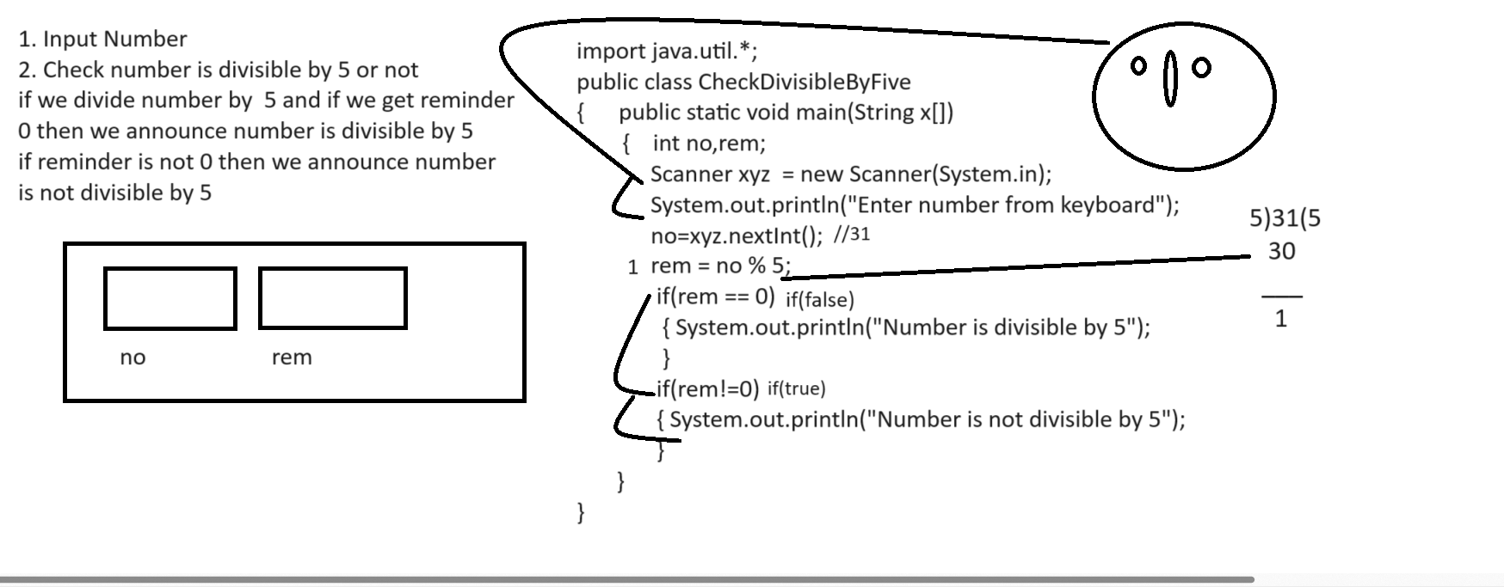
2. If else statement: when we have two conditions exact opposite of each other then we can use if else statement block.
Syntax:
if(condition){
write here true logics
}
else{
write here false logics
}
other program statement

Example: WAP to input number and check number is even or odd using if else statement.
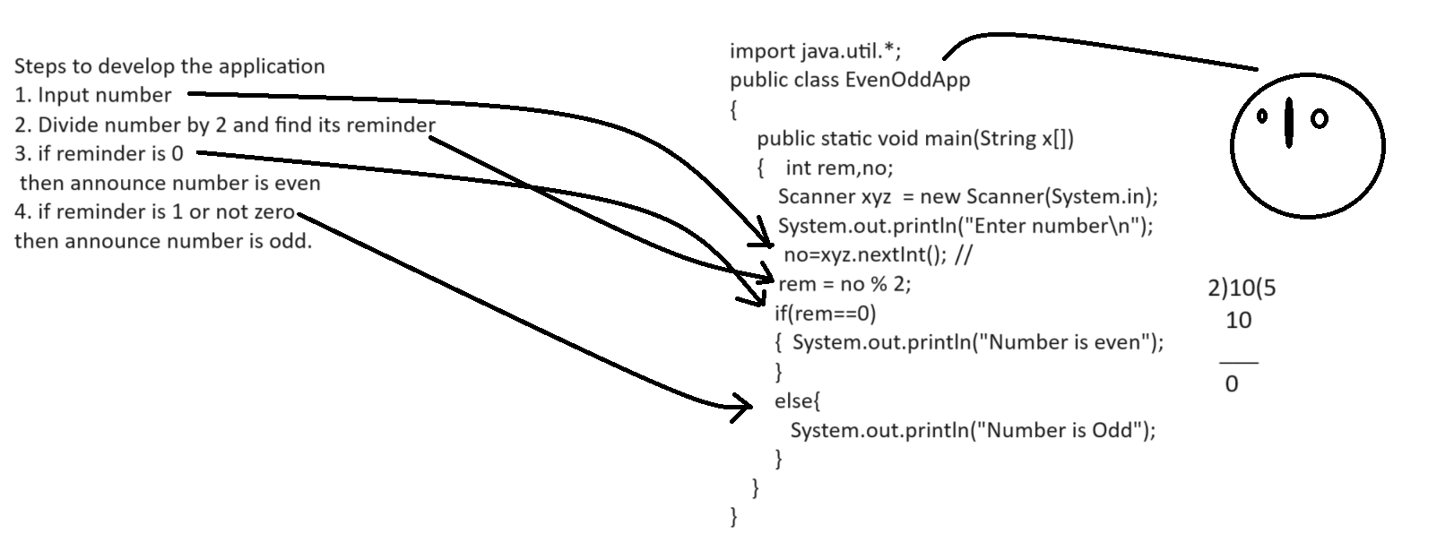
Example:
import java.util.*;
public class EvenOddApp
{
public static void main(String x[])
{ int no,rem;
Scanner xyz = new Scanner(System.in);
System.out.println("Enter number");
no=xyz.nextInt();
rem=no%2;
if(rem ==0)
{ System.out.println("Number is even");
}
else{
System.out.println("Number is Odd");
}
}
}

Example: WAP to input qty and rate of product and calculate its total and if bill amount is more than 5000 then give 20% discount on bill otherwise no discount.
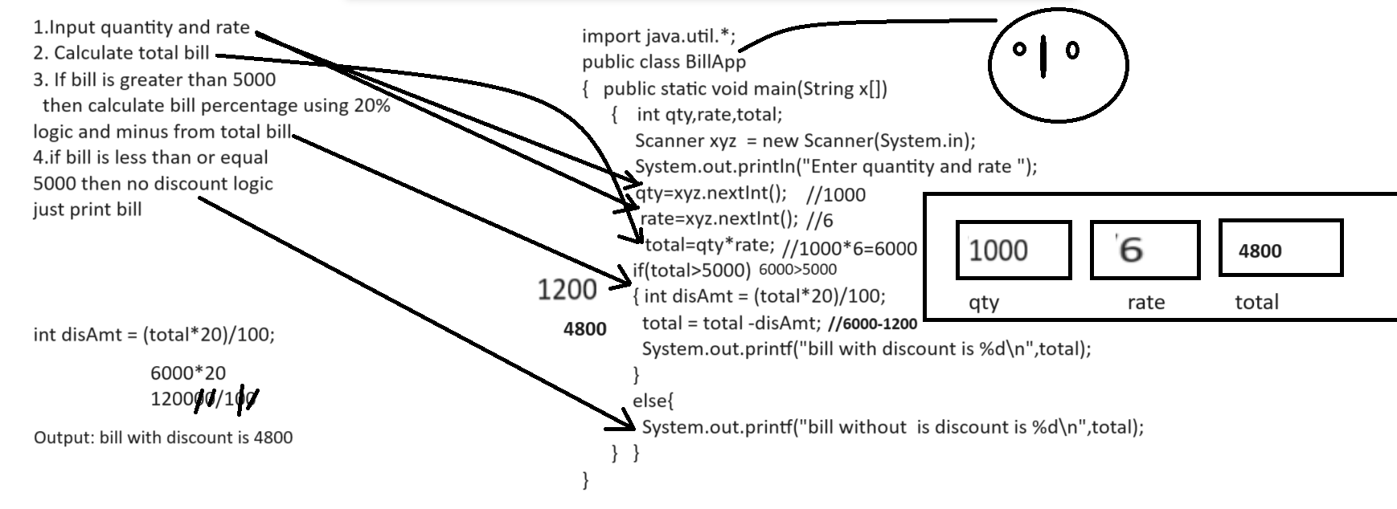

3. Else if ladder: else if ladder use when we have multiple conditions and every condition want to work as independent condition called as else if ladder.

Syntax: if (condition){
}
else if(condition){
}
else if(condition){
}
else{
}
Example: WAP to input three values and check which is greater
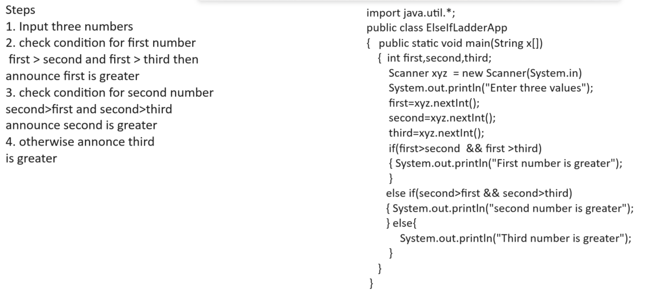
4. Nested if statement:
Nested if statement means if within if called as nested if
Syntax:
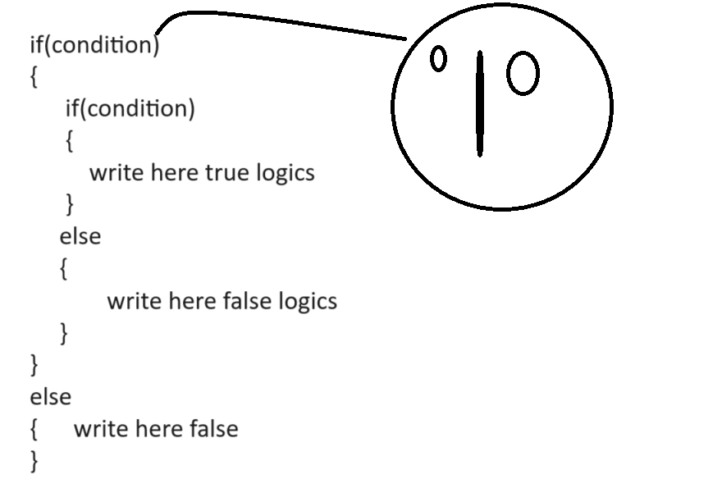
Note: Nested if use when we have more than one conditions and if some conditions are dependent on some another condition then we can use nested if statement.

Example: WAP to input the id and salary of employee
id between 1 to 100 and salary greater than 10000 then announce employee is
Permanent and if id between 1 to 100 and salary is less than 10000 then
Announce employee is temporary.

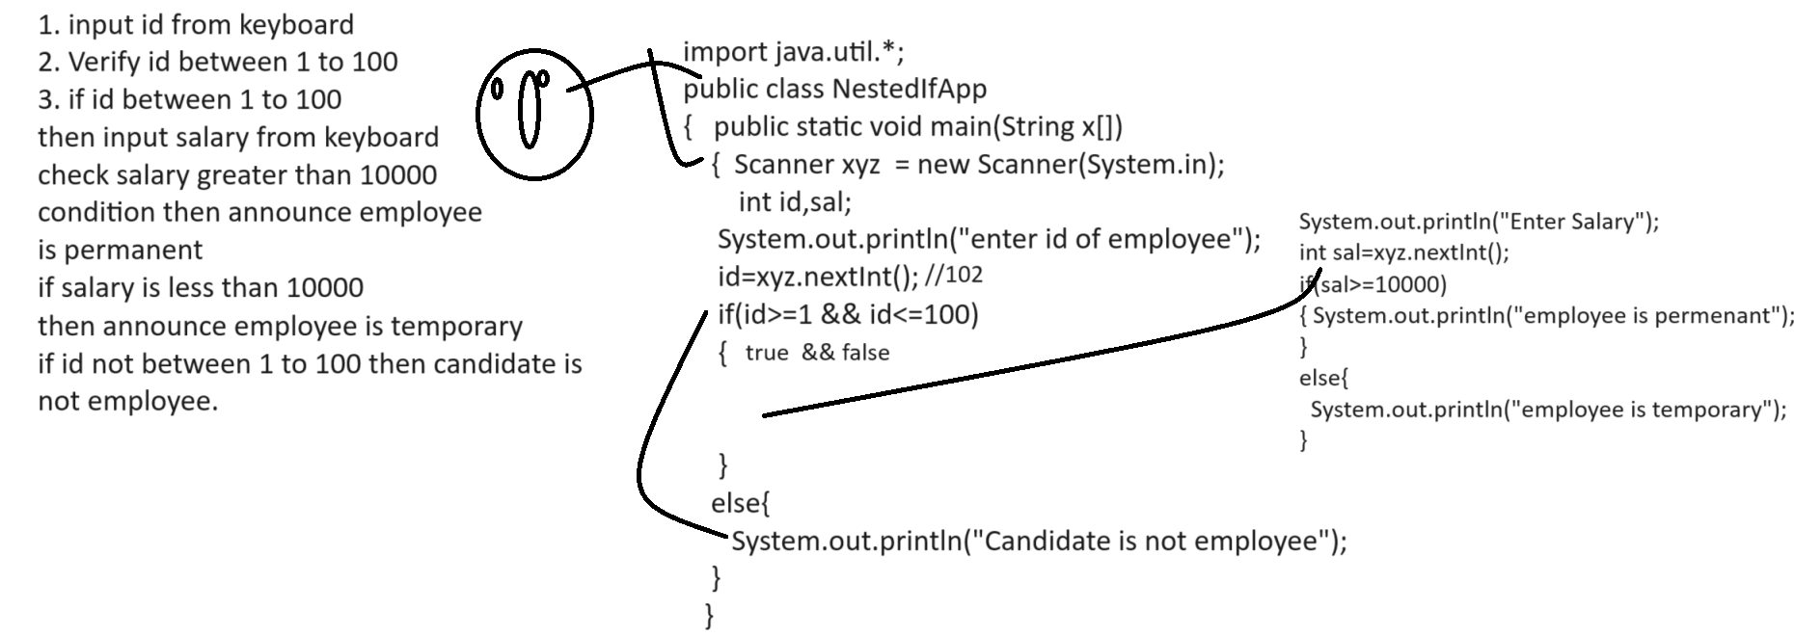

Example with source code
import java.util.*;
public class NestedIfApp
{
public static void main(String x[])
{
Scanner xyz = new Scanner(System.in);
int id,sal;
System.out.println("Enter id of employee");
id=xyz.nextInt();
if(id>=1 && id<=100)
{
System.out.println("Enter salary of employee");
sal=xyz.nextInt();
if(sal>=10000)
{
System.out.println("employee is permenant");
}
else{
System.out.println("employee is temporary");
}
}
else
{ System.out.println("candidate is not employee");
}
}
}

5. Switch Statement: switch statement is used for to work with choice based application or menu driven application.

Syntax:
switch(choice)
{ case 1:
write here your logics
break;
case 2:
write here your logics
break;
case 3:
write here your logics
break;
default:
write here your logics
}
Example: WAP to input two values and perform following operation on it.
Case 1: Addition
Case 2: Multiplication
Case 3: Division
Case 4: Subtraction

import java.util.*;
public class SwitchApp
{
public static void main(String x[])
{
Scanner xyz = new Scanner(System.in);
int a,b,choice;
System.out.println("1:Addition");
System.out.println("2:Multiplication");
System.out.println("3:Subtraction");
System.out.println("4:Division");
System.out.println("Enter your choice");
choice=xyz.nextInt();
System.out.println("Enter two values");
a=xyz.nextInt();
b=xyz.nextInt();
switch(choice)
{
case 1:
System.out.printf("Addition is %d\n",a+b);
break;
case 2:
System.out.printf("Multiplication is %d\n",a*b);
break;
case 3:
System.out.printf("Subtraction is %d\n",a-b);
break;
case 4:
System.out.printf("Division is %d\n",a/b);
break;
default:
System.out.println("Wrong choice");
}
}
}

Example: WAP to Create class name as AreaApplication and perform following operations
Case 1: Calculate Circle Area
Case 2: Calculate Rect Area

import java.util.*;
public class AreaApp
{
public static void main(String x[])
{
Scanner xyz =new Scanner(System.in);
int choice,l,w,rarea;
float rad,carea;
System.out.println("enter your choice");
choice=xyz.nextInt();
switch(choice)
{
case 1:
System.out.println("enter radius");
rad=xyz.nextFloat();
carea=rad*rad*3.14f;
System.out.printf("area of circle is %f\n",carea);
break;
case 2:
System.out.println("enter length and width");
l=xyz.nextInt();
w=xyz.nextInt();
rarea=l*w;
System.out.printf("Area of rectangle %d\n",rarea);
break;
default:
System.out.println("Wrong choice");
}
}
}

